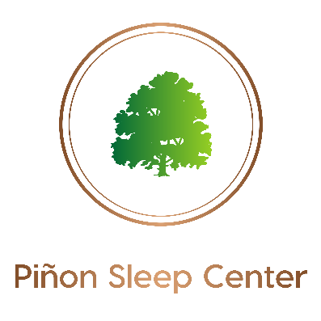

ACKNOWLEDGMENT OF OUR NOTICE OF PRIVACY PRACTICES

I hereby acknowledge that I have received or have been given the opportunity to receive a copy of Piñon Sleep Center’s Notice of Privacy Practices. By signing below I am “only” giving acknowledgment that I have received or have had the opportunity to receive the Notice of our Privacy Practices.

_________________________________________ __________________________________________
Patient Name (Type or Print) Name/Relationship if signed by other than patient

_________________________________________ __________________________________________
Signature Date

